

Final Project Proposal
Name: Abdul Haleem Abdullah
Student No: CL/BSCDS/CMU/09/25
Submission Date: 11/05/2026

Table of Contents
1. Title 3
2. Introduction 4
3. Current situation leading to problem identification 5
3.1 Current Situation 5
3.2 Problems in Existing Methods 5
3.3 Problem Statement 5
3.4 Proposed Direction Toward a Solution 5
4. Proposed technique to solve the current problem 6
4.1 Overview 6
4.2 Technologies Used 6
4.3 System Workflow 6
4.3 Expected Features 6
5. Feasibility analysis 8
6. Project description 9
6.1 Overview 9
6.2 Main Functional Modules 10
6.2.1. Image Upload Module 10
6.2.2. Disease Detection Module 10
6.6.3. Severity Analysis Module 10
6.6.4. Recommendation Module 11
6.6.5. Dashboard Module 11
7. Deliverables 12
8. Resources required 13
9. Expected output and outcome 14
10. Time plan for implementation 15
11. Limitations 16
12. References 17

Title

AI-Powered Coconut Leaf Disease Detection and Health Monitoring System

Project Overview
The proposed project focuses on developing an AI-powered web-based system capable of detecting coconut leaf diseases using deep learning and computer vision technologies. Coconut leaf diseases can significantly reduce plantation productivity and economic value if they are not identified during the early stages. Traditional disease detection methods mainly depend on manual inspection, which is often time-consuming and inaccurate.
The proposed system allows users to upload coconut leaf images and receive real-time disease predictions, severity analysis, and treatment recommendations. The system uses Convolutional Neural Networks (CNNs) with transfer learning models such as MobileNetV2 to improve classification accuracy and performance.
In addition, the system includes a plantation health monitoring dashboard for analyzing disease statistics, prediction history, and plantation conditions. The system aims to support farmers and agricultural officers by providing a fast, affordable, and user-friendly disease monitoring solution.

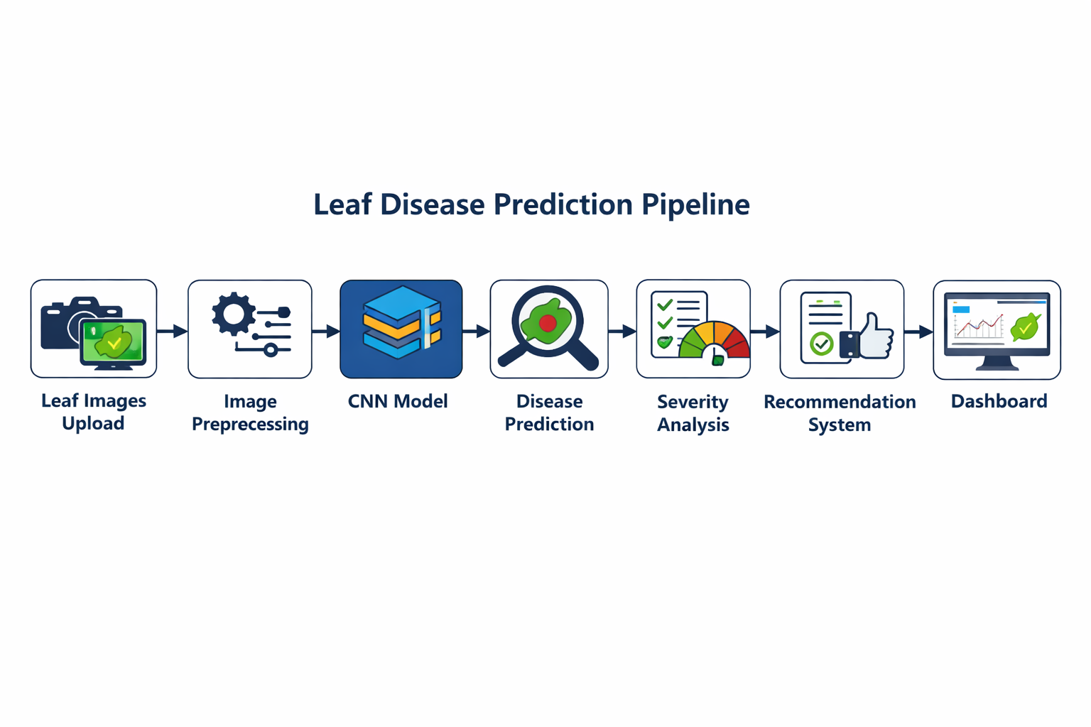

Introduction

Agriculture plays an important role in the economy of many tropical countries, and coconut cultivation is one of the major agricultural industries in Sri Lanka. Coconut trees provide several economic benefits through products such as coconut oil, coconut milk, and fiber. However, coconut plantations are highly affected by leaf diseases that can reduce crop quality and productivity.
Traditional disease detection methods mainly rely on manual inspection by farmers or agricultural experts. These methods are often slow, inaccurate, and dependent on human experience. In many cases, diseases are identified only after severe symptoms appear, causing significant plantation losses.
Recent advancements in Artificial Intelligence (AI), Machine Learning (ML), and Computer Vision technologies have enabled the development of smart agricultural systems. Convolutional Neural Networks (CNNs) can automatically identify disease-related patterns such as discoloration, texture changes, and infected regions from leaf images with high accuracy.
This project proposes an AI-Powered Coconut Leaf Disease Detection and Plantation Health Monitoring System that uses deep learning techniques for accurate disease classification and plantation monitoring. The system also provides disease severity estimation, treatment recommendations, and prediction history through a web-based dashboard developed using React, Tailwind CSS, and Flask.

Current situation leading to problem identification

3.1 Current Situation
Currently, coconut leaf diseases are mainly identified through manual inspection by farmers or agricultural officers. Disease detection is based on visible symptoms such as yellowing leaves, dark spots, and drying patterns. This method is time-consuming, inaccurate, and highly dependent on human experience.
In large plantations, regular monitoring becomes difficult, causing diseases to spread before proper treatment is provided. Small-scale farmers also face difficulties in accessing agricultural experts for accurate diagnosis.

3.2 Problems in Existing Methods
Traditional disease detection methods have several limitations:
- Delayed disease identification.
- Human errors during inspection.
- Difficulty in monitoring large plantations.
- Increased crop and financial losses.
- Lack of automated monitoring systems.
Although some AI-based systems exist, many focus only on image classification and do not provide plantation monitoring or user-friendly web access.

3.3 Problem Statement
Currently, there is no affordable AI-powered web-based system capable of accurately detecting coconut leaf diseases while supporting plantation health monitoring and disease management.

3.4 Proposed Direction Toward a Solution
The proposed system uses CNN-based deep learning techniques to detect coconut leaf diseases from uploaded images. The system also provides severity analysis, treatment recommendations, and plantation monitoring through a web-based dashboard.
Comparison of Existing Methods and Proposed Solution
Existing Methods | Limitations
Manual Inspection | Human error and slow detection
Traditional Monitoring | Difficult to monitor large plantations
Basic AI Systems | Limited features and accessibility
Proposed System | AI detection with monitoring dashboard

Proposed technique to solve the current problem

Overview
The proposed system is an AI-powered web application designed to detect coconut leaf diseases using deep learning and computer vision techniques. The system allows users to upload coconut leaf images and receive real-time disease predictions along with severity analysis and treatment recommendations.
The project uses Convolutional Neural Networks (CNNs) with transfer learning models such as MobileNetV2 to improve prediction accuracy and reduce training time. The system is designed to provide a fast, affordable, and user-friendly solution for farmers and agricultural officers.

4.2 Technologies Used
- Frontend: React.js and Tailwind CSS
- Backend: Flask
- AI Model: TensorFlow / Keras
- Image Processing: OpenCV
- Database: Firebase or MySQL

4.3 System Workflow
The system follows several main stages:
- Image Upload – Users upload coconut leaf images through the web application.
- Image Preprocessing – Images are resized and normalized before prediction.
- Disease Detection – The CNN model analyzes the image and predicts the disease category.
- Severity Analysis – The system estimates the infection level as Mild, Moderate, or Severe.
- Recommendation System – Treatment and prevention suggestions are provided.
- Dashboard Monitoring – Prediction history and disease statistics are stored and displayed.

4.3 Expected Features
- Real-time disease prediction.
- Image-based disease analysis.
- Severity estimation.
- Plantation health monitoring dashboard.
- Treatment recommendations.
- Prediction history tracking.
Main System Components
Component | Purpose
React + Tailwind | User interface
Flask | Backend API
CNN Model | Disease prediction
OpenCV | Image preprocessing
Dashboard | Monitoring and analytics

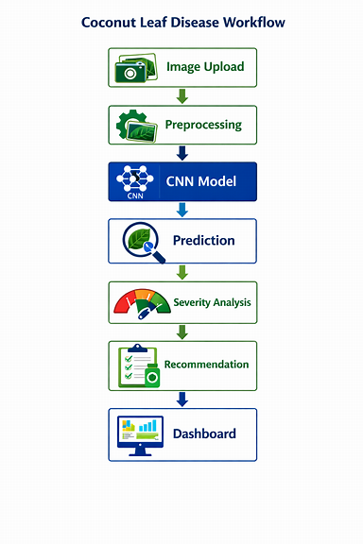

Feasibility analysis
The feasibility of the proposed Coconut Leaf Disease Detection and Plantation Health Monitoring System can be evaluated through technical, economic, and operational feasibility. These factors help determine whether the project can be successfully developed and implemented using the available resources.
- Technical Feasibility

The project is technically feasible because it uses widely available technologies such as TensorFlow, OpenCV, Flask, React, and Tailwind CSS. The Kaggle Coconut Leaves Disease Dataset provides sufficient image data for training and testing the CNN model.
The system can also be developed using standard hardware with cloud GPU support through platforms such as Google Colab or Kaggle Notebooks.
- Economic Feasibility
The project is cost-effective because most tools and technologies used are open-source and freely available. Development platforms such as Google Colab, VS Code, and GitHub reduce implementation costs.
The proposed system may also help reduce plantation losses by enabling early disease detection and better disease management.
- Operational Feasibility
The system is designed to be simple and user-friendly for farmers and agricultural officers. Users only need to upload coconut leaf images to receive predictions and recommendations.
The web-based dashboard allows users to monitor plantation conditions and prediction history easily through a standard web browser.

Feasibility Analysis Summary
Feasibility Type | Description
Technical Feasibility | AI and web technologies are available and easy to implement
Economic Feasibility | Uses low-cost and open-source tools
Operational Feasibility | Simple and user-friendly web system

Project description

6.1 Overview
The proposed system is a web-based AI application developed to detect coconut leaf diseases and support plantation health monitoring. The system uses deep learning and computer vision techniques to analyze coconut leaf images and provide accurate disease predictions.
Users can upload coconut leaf images through the web application and receive real-time predictions, severity analysis, and treatment recommendations. The system is designed to help farmers and agricultural officers identify diseases quickly and reduce plantation losses.

6.2 Main Functional Modules

6.2.1. Image Upload Module
This module allows users to upload coconut leaf images through the web application. The uploaded images are validated before being processed by the AI model. The interface is designed to be simple and user-friendly so that farmers and agricultural officers can easily use the system without technical knowledge.
Main functions:

- Upload leaf images
- Validate image format
- Preview uploaded images
- Send images for processing

6.2.2. Disease Detection Module
The Disease Detection Module is the core component of the system. It uses a Convolutional Neural Network (CNN) model with transfer learning techniques to identify coconut leaf diseases from uploaded images.
The model analyzes features such as:
- Color changes
- Dark spots
- Leaf discoloration
- Texture abnormalities
- Infection patterns
After analysis, the system predicts the disease category and displays the confidence score.
Example:
Leaf Spot Disease – 92% Confidence

6.6.3. Severity Analysis Module
This module estimates the severity level of the detected disease based on the infected area visible on the leaf image.
Severity levels include:
- Mild
- Moderate
- Severe
The severity analysis helps users understand the seriousness of the infection and supports better treatment planning.

6.6.4. Recommendation Module
Based on the prediction result, the system provides treatment recommendations and prevention methods to help users manage diseases effectively.
Recommendations may include:
- Fertilizer suggestions
- Fungicide recommendations
- Leaf removal guidance
- Disease prevention methods
- Plantation maintenance advice
This module improves the practical usefulness of the system for real-world agricultural applications.

6.6.5. Dashboard Module
The dashboard module provides plantation monitoring and analytical features. All prediction records are stored and displayed through visual charts and statistics.
Dashboard features include:
- Prediction history
- Disease frequency analysis
- Severity distribution
- Plantation monitoring charts
- Confidence score tracking
The dashboard helps users monitor plantation conditions and identify common disease patterns over time.

Deliverables
The project deliverables represent the final outputs and components produced during the development of the Coconut Leaf Disease Detection and Plantation Health Monitoring System.
Main Deliverables
1. Trained CNN Model
A deep learning model capable of accurately detecting coconut leaf diseases from uploaded images.
2. Web-Based Application
A responsive web application developed using React, Tailwind CSS, and Flask for disease prediction and plantation monitoring.
3. Disease Severity Analysis Module
A module capable of estimating disease severity levels such as Mild, Moderate, and Severe.
4. Recommendation System
A feature that provides treatment methods and disease prevention recommendations based on prediction results.
5. Plantation Monitoring Dashboard
An analytical dashboard displaying disease statistics, prediction history, and plantation monitoring information.
6. Preprocessed Dataset
A cleaned and organized coconut leaf image dataset prepared for CNN model training and evaluation.
7. Project Documentation
Complete project documentation including proposal, system design, testing results, and final report.

Resources required
The development of the proposed system requires several hardware, software, and development resources to support model training, web application development, and system deployment.
Hardware Requirements
The project can be developed using a standard laptop or desktop computer with moderate specifications.
Recommended hardware includes:
- Intel i5/Ryzen 5 processor or higher
- Minimum 8GB RAM
- SSD storage
- Smartphone or camera for capturing leaf images
Software Requirements
Several software tools and libraries will be used during development.
Development Technologies
- React.js
- Tailwind CSS
- Flask
- Python
AI and Image Processing Libraries
- TensorFlow / Keras
- OpenCV
- NumPy
- Pandas
- Matplotlib
Development Platforms
- VS Code
- GitHub
- Google Colab
- Kaggle Notebooks
Dataset Resource
The project uses the Kaggle Coconut Diseases Dataset, which contains multiple coconut leaf disease images collected under different environmental conditions.
https://www.kaggle.com/datasets/samitha96/coconutdiseases/data

Expected output and outcome
Expected Output
The proposed system is expected to generate several useful outputs related to coconut leaf disease detection and plantation monitoring.
1. Disease Prediction
The system will classify uploaded coconut leaf images into disease categories such as healthy leaves and infected leaves.
2. Confidence Score
Each prediction will include a confidence percentage indicating the accuracy of the prediction.
3. Severity Analysis
The system will estimate the disease severity level as Mild, Moderate, or Severe.
4. Recommendation System
Treatment suggestions and disease prevention methods will be provided based on the detected disease.
5. Monitoring Dashboard
The dashboard will display prediction history, disease statistics, and plantation monitoring analytics.
Expected Outcome
The proposed system is expected to improve early disease detection and support better plantation management. Farmers and agricultural officers will be able to identify diseases faster and take preventive actions before diseases spread across plantations.
The project also demonstrates the practical use of Artificial Intelligence and Deep Learning technologies in agriculture while reducing plantation losses and improving productivity.

Time plan for implementation
The project will be completed over a 12-week period, divided into structured phases covering data collection, model development, testing, and reporting. This plan ensures organized progress and proper time management.
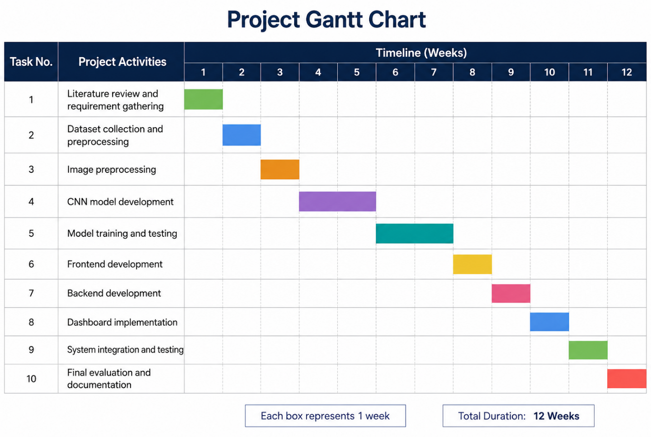

Limitations
Although the proposed Coconut Leaf Disease Detection and Plantation Health Monitoring System provides several advantages, certain limitations may affect system performance and implementation.
1. Limited Disease Categories
The current dataset contains a limited number of coconut leaf disease categories. Therefore, the system may not accurately identify diseases that are not included in the training dataset. Future improvements can include expanding the dataset with additional disease classes and real-world samples.
2. Image Quality Dependency
The prediction accuracy may be affected by poor image quality, including blurry images, low lighting conditions, or complex backgrounds. Proper image preprocessing and dataset augmentation techniques will be used to reduce this limitation.
3. Environmental Variations
Different environmental conditions such as lighting, shadows, and camera angles may influence prediction performance in real-world scenarios. Training the model using diverse images can improve model robustness.
4. Hardware Constraints
Training deep learning models may require higher computational resources and GPU support. Cloud-based platforms such as Google Colab and Kaggle will be used to overcome hardware limitations.
5. Model Generalization
The trained model may perform differently on unseen real-world data compared to the training dataset. Continuous testing and dataset improvements can help improve model generalization and prediction accuracy.

References
- Engelbart, E. (2023) How to Extend the Shelf Life of Fruits and Vegetables with Science. University of Texas News. Available at: https://cns.utexas.edu/news/features/how-extend- shelf-life-fruits-and-vegetables-science [Accessed 10 May. 2026].
- FoodInformatics Review (2024) Challenges in AI-Based Food Shelf-Life Prediction. University of Hohenheim. Available at: https://www.uni-hohenheim.de/ [Accessed 10 May. 2026].
- Hoffmann, T.G. (2023) Fresh food shelf-life improvement by humidity regulation in storage environments. ScienceDirect. Available at: https://www.sciencedirect.com/science/article/pii/S1877050922023572 [Accessed 10 May. 2026].
- IEEE Paper (2024) Deep Learning-Based Fruit Freshness Detection Using Convolutional Neural Networks (Paper No. 10891620). IEEE Xplore. Available at: https://ieeexplore.ieee.org/document/10891620 [Accessed 10 May. 2026].
- Kuhl, E. (2025) AI for food: accelerating and democratizing discovery and innovation. Nature. Available at: https://www.nature.com/articles/s41538-025-00441-8 [Accessed 10 May. 2026].
- Kumar, R. and Gupta, S. (2023) Fruit Quality Detection using Ensemble CNNs. ScienceDirect. Available at: https://www.sciencedirect.com/ [Accessed 10 May. 2026].
- Li, Y. et al. (2024) Deep Learning Approaches for Fruit Freshness Classification. MDPI. Available at: https://www.mdpi.com/ [Accessed 10 May. 2026].
- Liu, H. (2023) Virtual Cold Chain Method to Evaluate the Effect of Rising Temperatures on Fruit Quality. PMC. Available at: https://pmc.ncbi.nlm.nih.gov/articles/PMC10297325/ [Accessed 10 May. 2026].
- MDPI (2025) AI Applications in Food Quality Control. MDPI. Available at: https://www.mdpi.com/ [Accessed 10 May. 2026].
- Mulla, A. and Dhamal, A. (2025) AI-based food spoilage detection (Computer Vision + Sensor Data). IJPREMS. Available at: https://www.ijprems.com/uploadedfiles/paper/issue_4_april_2025/39563/final/fin_ijprems17 43712616.pdf [Accessed 10 May. 2026].

- Patel, V. et al. (2025) RGB-Thermal Hybrid Learning for Vegetable Decay Prediction. MDPI. Available at: https://www.mdpi.com/ [Accessed 10 May. 2026].
- Purdue University News (2025) Consumers mostly support AI tools to improve food and agriculture. Purdue Agriculture. Available at: https://ag.purdue.edu/news/2025/09/consumers-mostly-support-ai-tools-to-improve-food- and-agriculture.html [Accessed 10 May. 2026].
- Rahman, H. et al. (2024) IoT-Based Monitoring of Mango Freshness in Cold Chain Systems. IEEE Access. Available at: https://ieeexplore.ieee.org/ [Accessed 10 May. 2026].
- ScienceDirect (2024) AI and Environmental Modeling in Food Supply Chains. Elsevier. Available at: https://www.sciencedirect.com/ [Accessed 10 May. 2026].
- Sonwani, E. (2022) An Artificial Intelligence Approach Toward Food Spoilage. PMC. Available at: https://pmc.ncbi.nlm.nih.gov/articles/PMC8802332/ [Accessed 10 May. 2026].
- Sowmiya, R., Chanstar, S., Banu, S. and Kumar, R. (2024) Predicting Shelf-Life of Fruits: A Multifactorial Approach using Intrinsic and Extrinsic Determinants. IJRASET. Available at:https://www.ijraset.com/research-paper/predicting-shelf-life-of-fruits-a-multifactorial- approach-using-intrinsic [Accessed 10 May. 2026].
- Torres-Sánchez, R. (2020) Real-Time Monitoring System for Shelf Life Estimation of Fruit. PMC. Available at: https://pmc.ncbi.nlm.nih.gov/articles/PMC7180900/ [Accessed 10 May. 2026].
- University of Maine Extension (n.d.) Storage Conditions: Fruits and Vegetables, Bulletin #4135. Cooperative Extension. Available at: https://extension.umaine.edu/publications/4135e/ [Accessed 10 May. 2026].
- Zhang, L. et al. (2023) Predicting Banana Shelf-Life using Temperature and Humidity Models. ScienceDirect. Available at: https://www.sciencedirect.com/ [Accessed 10 May. 2026].
- Zhou, J. et al. (2024) Multimodal Sensor Fusion for Apple Freshness Estimation. IEEE Access. Available at: https://ieeexplore.ieee.org/ [Accessed 10 May. 2026].
- Kaggle (2026) Coconut Diseases Dataset. Available at: Kaggle Coconut Diseases Dataset [Accessed 10 May 2026].
- Howard, A. et al. (2019) Searching for MobileNetV3. arXiv. Available at: arXiv MobileNet Paper [Accessed 10 May 2026].

- TensorFlow (2026) TensorFlow Documentation. Available at: TensorFlow Official Website [Accessed 10 May 2026].

- OpenCV (2026) OpenCV Library Documentation. Available at: OpenCV Official Website [Accessed 10 May 2026].

- Too, E.C., Yujian, L., Njuki, S. and Yingchun, L. (2019) A Comparative Study of Fine-Tuning Deep Learning Models for Plant Disease Identification. Computers and Electronics in Agriculture. Available at: ScienceDirect Plant Disease Identification Study [Accessed 10 May 2026].

- Goodfellow, I., Bengio, Y. and Courville, A. (2016) Deep Learning. MIT Press. Available at: Deep Learning Book [Accessed 10 May 2026].

- Shorten, C. and Khoshgoftaar, T.M. (2019) A Survey on Image Data Augmentation for Deep Learning. Journal of Big Data. Available at: Springer Image Augmentation Survey [Accessed 10 May 2026].

